Pumpkin Spice Funnel Cakes with

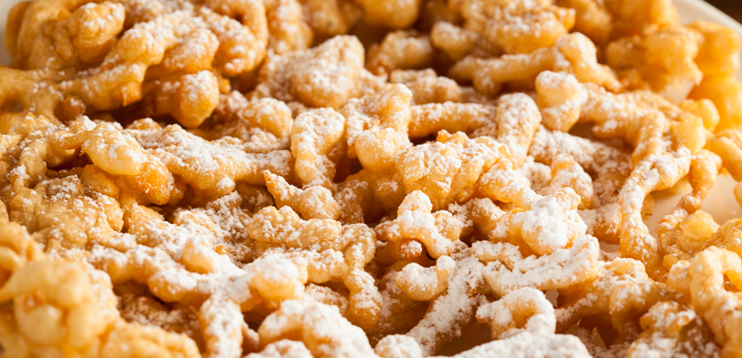
#5100 Pennsylvania Dutch Funnel Cake Mix

Serve up some pumpkin spice funnel cakes with this easy recipe.

Ingredients
- #5100 Pennsylvania Dutch Funnel Cake Mix
- 1 cup #1391 Pumpkin Spice Mix
- Water - add amount per funnel cake mix directions
- Frying Oil

Directions
- Preparing the funnel cake batter
  - Pour water into a a large container
  - Using a blender on slow speed, or a whisk, slowly add the funnel cake mix
  - Add in the #1391 Pumpkin Spice Mix
  - Blend until the batter is smooth
  - Pour the batter into a funnel pouring pitcher
- Making Your Funnel Cake
  - Fill your shallow fryer to the recommended level with vegetable oil and heat to 400 degrees F.
  - Place the funnel cake mold in the fryer
  - Pour batter into the mold from a funnel cake pitcher, starting with a circle of batter near the outer edge of the mold, then making a zig-zag overlapping design touching the outer edge circle.
  - Do not overfill mold since the batter will expand as it cooks
  - After approximately 30 seconds remove the mold and turn the funnel cake over with tongs to achieve a golden brown on both sides.
  - Remove the funnel cake and let it cool briefly.
  - Top with powdered sugar, ice cream, honey or any kind of your favorite toppings.

